Kafka Points:

Event Driven Architecture:

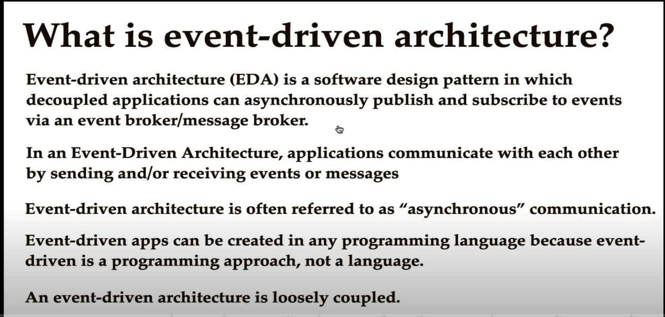

In Event driven architecture applications are loosely coupled. Order Service does not need to have details about Stock Service.

* Improves Flexibility and Maintainability (Applications are independent so easy to maintain)
* High Scalability, so you can create as many micro services as possible and can consume messages.
* Improved Availability. If one Micro service is down, it wont affect other Micro services
* If the producer specifies a partition number explicitly in the message, use the provided partition number.
* If the producer does **not** specify a partition number but provides a key, choose the partition based on the hash value of the key.
* When the producer is extremely rude and does **not** send either a partition number of a key, assign partition using the **tried-and-tested** round-robin approach. The round-robin approach has now been replaced with **Sticky Partitioner** approach but more on that in a later post.

Problems with Kafka Default Partitioner

As you may have guessed, the idea of a default partitioner looks good on paper, but it has a few problems that cannot be ignored:

* **Hashing guarantees give you the same number for same key values. But it can also give you the same number for different key values**. This is a problem if we want to make sure that certain partitions are reserved for only certain key values.
* The **default partitioner calculates the partition number using the total number of partitions in a topic** (hashcode(key) % numberOfPartitions). This is a huge problem if we decide to increase the number of partitions for a topic in the future. The partition number calculation will completely change.
* **Default partitioner can also create issues in the case of composite keys**. For example, if our key comprises of order id and timestamp, the hash value will change for different timestamps. This means that data for same order id can go to different partitions.

To increase the reliability and fault tolerance,replications of the partitions are made and they do not increase the consumer parallelism.**The thumb rule is a single broker can host only a single replica per partition**. Hence Number of brokers must be >= No of replicas

All partitions are spread across all the available brokers,number of partitions can be irrespective of number of brokers but number of partitions must be equal to the number of consumer threads in a consumer group(to get best throughput)

**Kafka vs Rabbit MQ:**

One important difference between Kafka and RabbitMQ is that the first is pull-based, while the other is push-based. In pull-based systems, the brokers waits for the consumer to ask for data (‘pull’); if a consumer is late, it can catch up later. With push-based systems, messages are immediately pushed to any subscribed consumer. This can cause these two tools to behave differently in some circumstances.

|  |  |  |
| --- | --- | --- |
| **Tool** | **Apache Kafka** | **RabbitMQ** |
| Message ordering | provides message ordering thanks to its partitioning. Messages are sent to topics by message key. | Not supported. |
| Message lifetime | Kafka is a log, which means that it retains messages by default. You can manage this by specifying a retention policy. | RabbitMQ is a queue, so messages are done away with once consumed, and acknowledgment is provided. |
| Delivery Guarantees | Retains order only inside a partition. In a partition, Kafka guarantees that the whole batch of messages either fails or passes. | Doesn’t guarantee atomicity, even in relation to transactions involving a single queue. |
| Message priorities | N/A | In RabbitMQ, you can specify message priorities and consume message with high priority first. |
| Performance | Kafka offers much higher performance than message brokers like RabbitMQ. It uses sequential disk I/O to boost performance, making it a suitable option for implementing queues. It can achieve high throughput (millions of messages per second) with limited resources, a necessity for big data use cases. | RabbitMQ can also process a million messages per second but requires more resources (around 30 nodes). You can use RabbitMQ for many of the same use cases as Kafka, but you’ll need to combine it with other tools like Apache Cassandra. |

It is not recommended to run Kafka on the JVM on Windows, because it lacks some of the linux-specific features of POSIX for example. You will run into issues at some point if you try to run Kafka on Windows without WSL2.

WSL2 is Windows Subsystem for Linux 2 and provides a Linux environment for your Windows computer that does not require a virtual machine

Conduktor **gives our engineers the tools they need to build, operate, diagnose, and extend our Kafka-based workloads with ease**.”

1. How Kafka Producer decides to which partition to put data based on key
2. In case of Kafka Broker failures, Producers will automatically recover

* **Topics**:
* a particular stream of data like logs, purchases, twitter_tweets. It is like a table in the database (without all the constraints)
* You can have as many topics as you want.
* Any kind of message format.
* The sequence of messages is called a data stream.

**Partitions and Offsets:**

* Topics are split in partitions.
* Messages within partition are ordered.

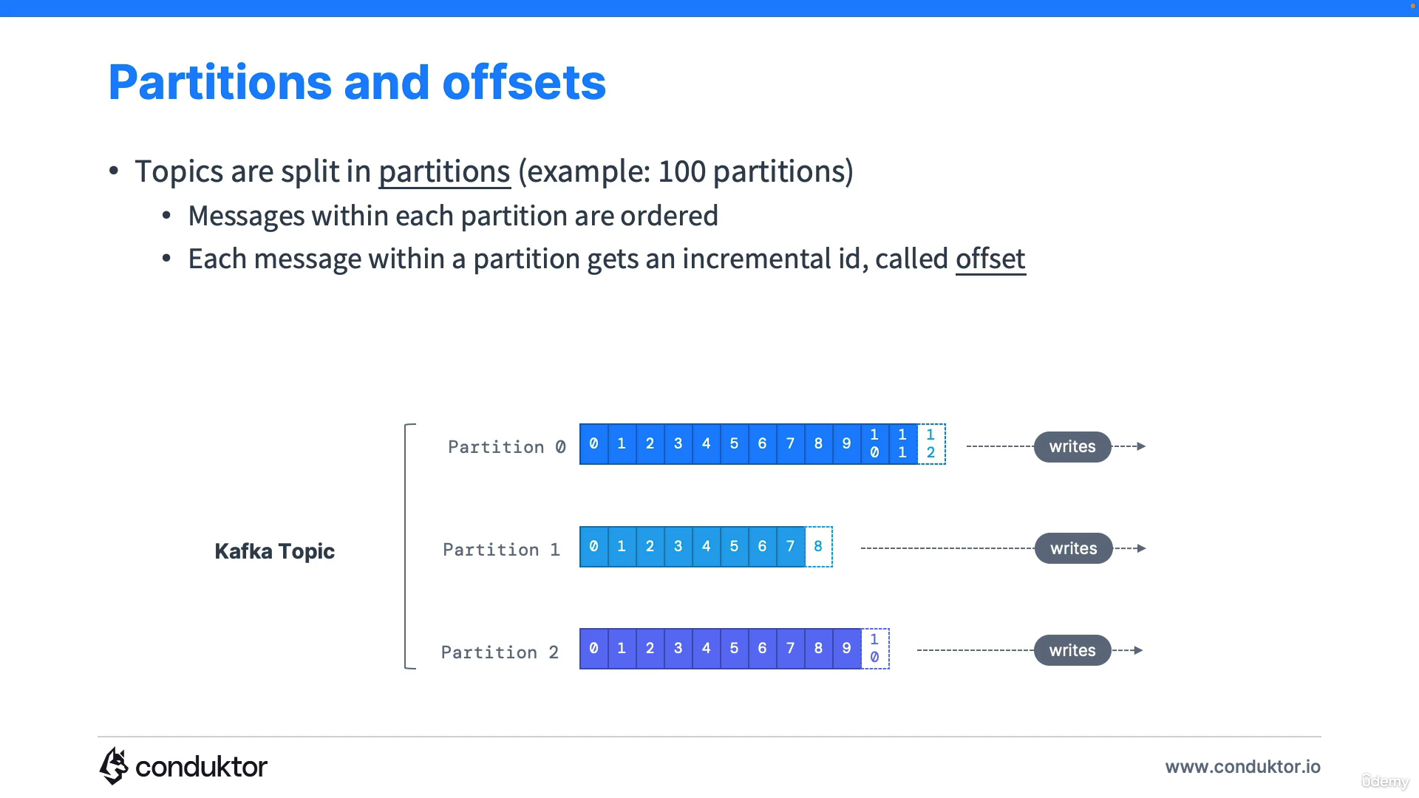

* Kafka topics are immutable: once data is written to a partition, it cannot be changed.
* Offset only have a meaning for a specific position.
* E.g., Offset 3 in partition 0 doesn’t represent the same data as offset 3 in partition 1.
* Offset are not re used even if previous message have been deleted.
* Order is guaranteed only within a partition (not across partitions).
* Data is assigned randomly to a partition unless a key is provided.

**Producers:**

* 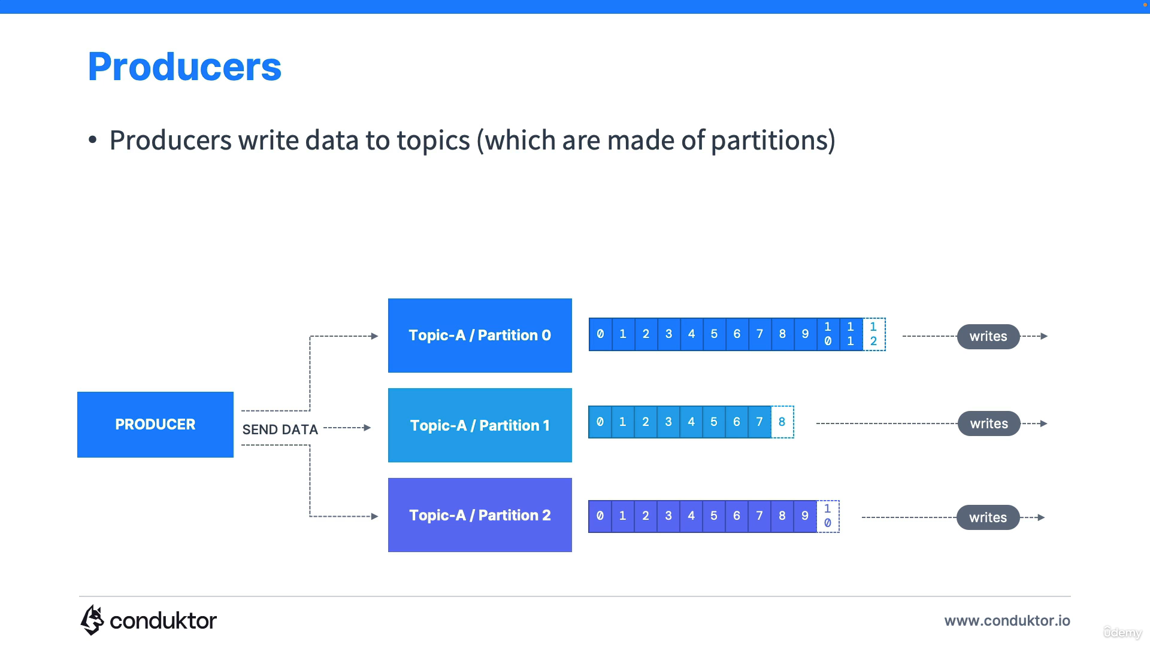
* Producers know to which partition to write to
* Producers can choose to send a key with the message(string, number, binary etc)
* 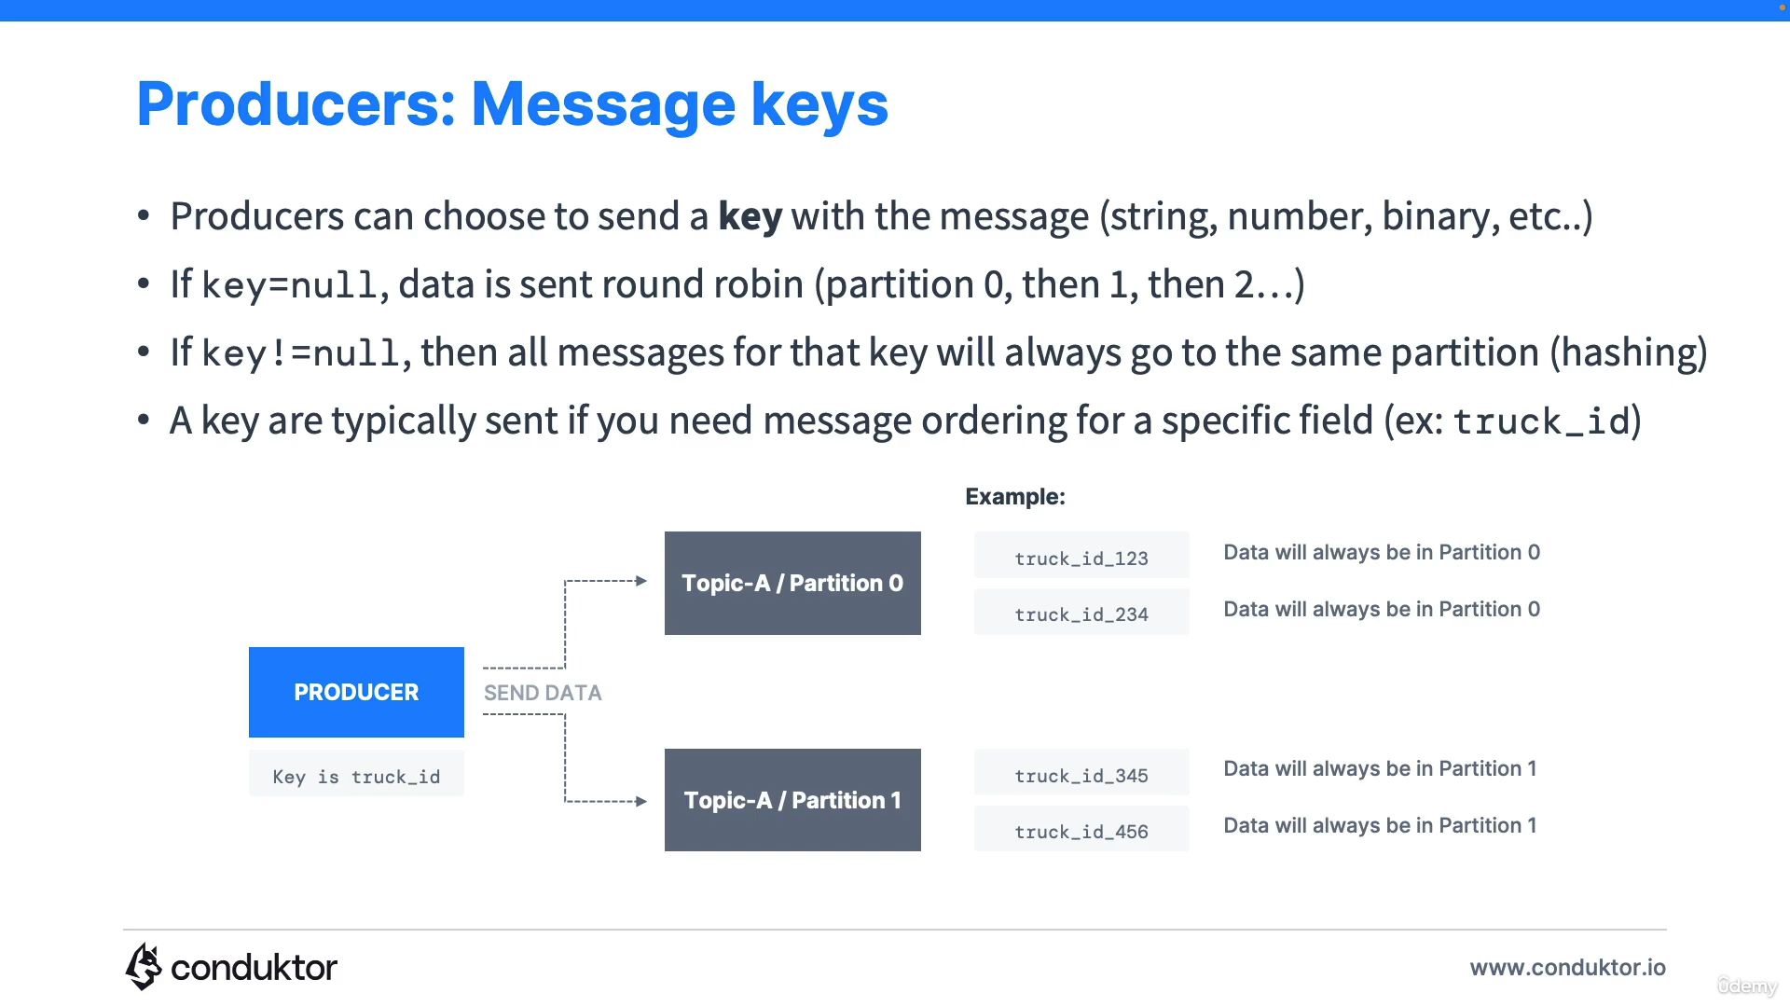

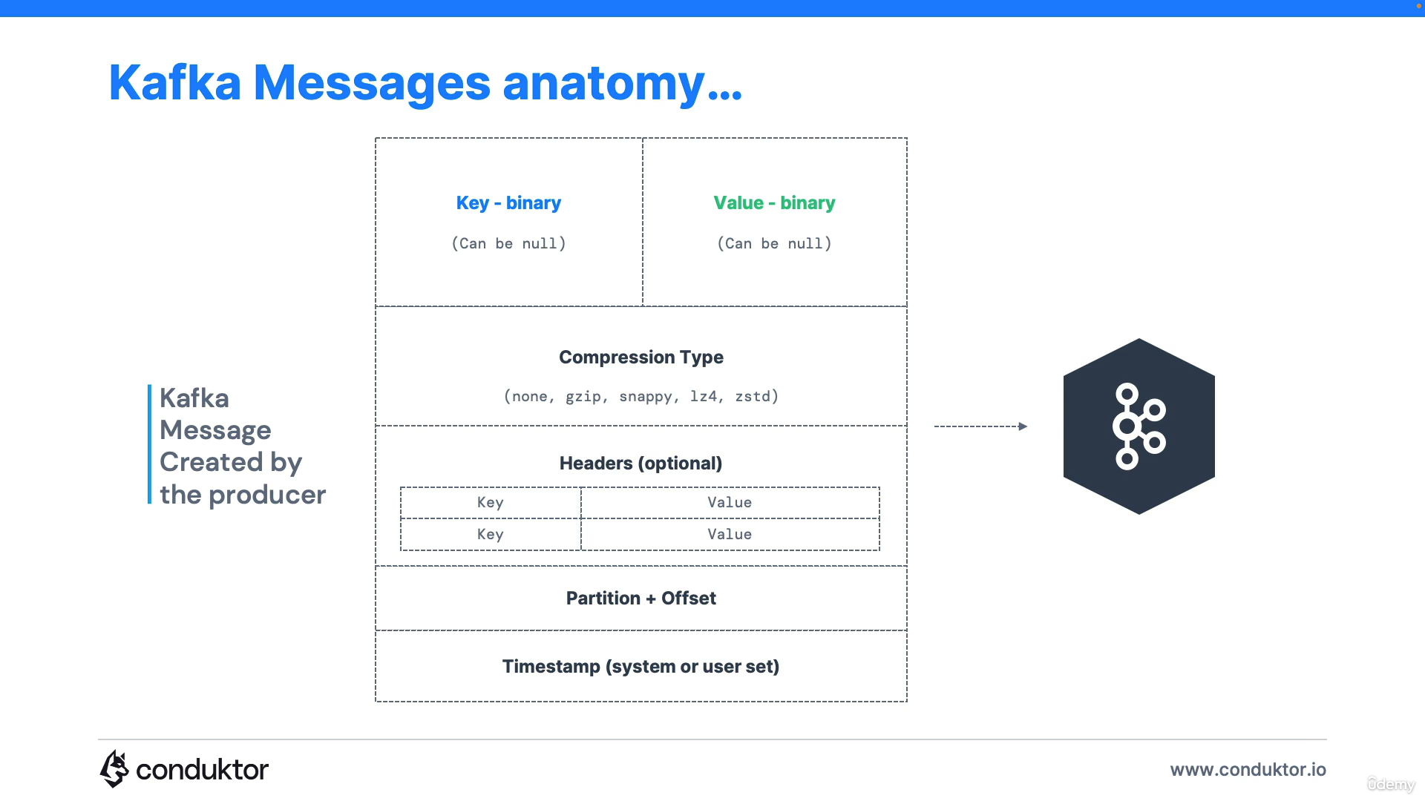

**Kafka Message Serializer:**

Kafka only accepts bytes as an input from producers and sends bytes out as an output to consumers.

Message Serialization means transforming objects/data into bytes.

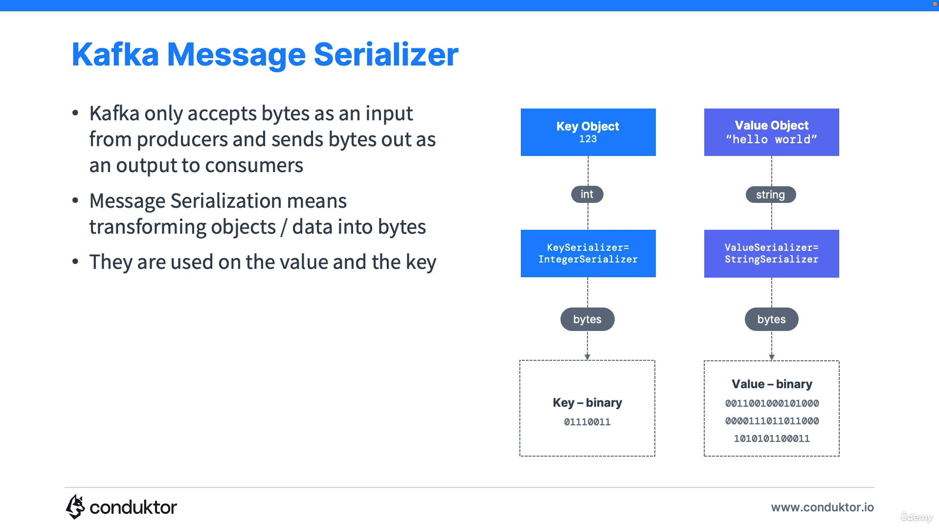

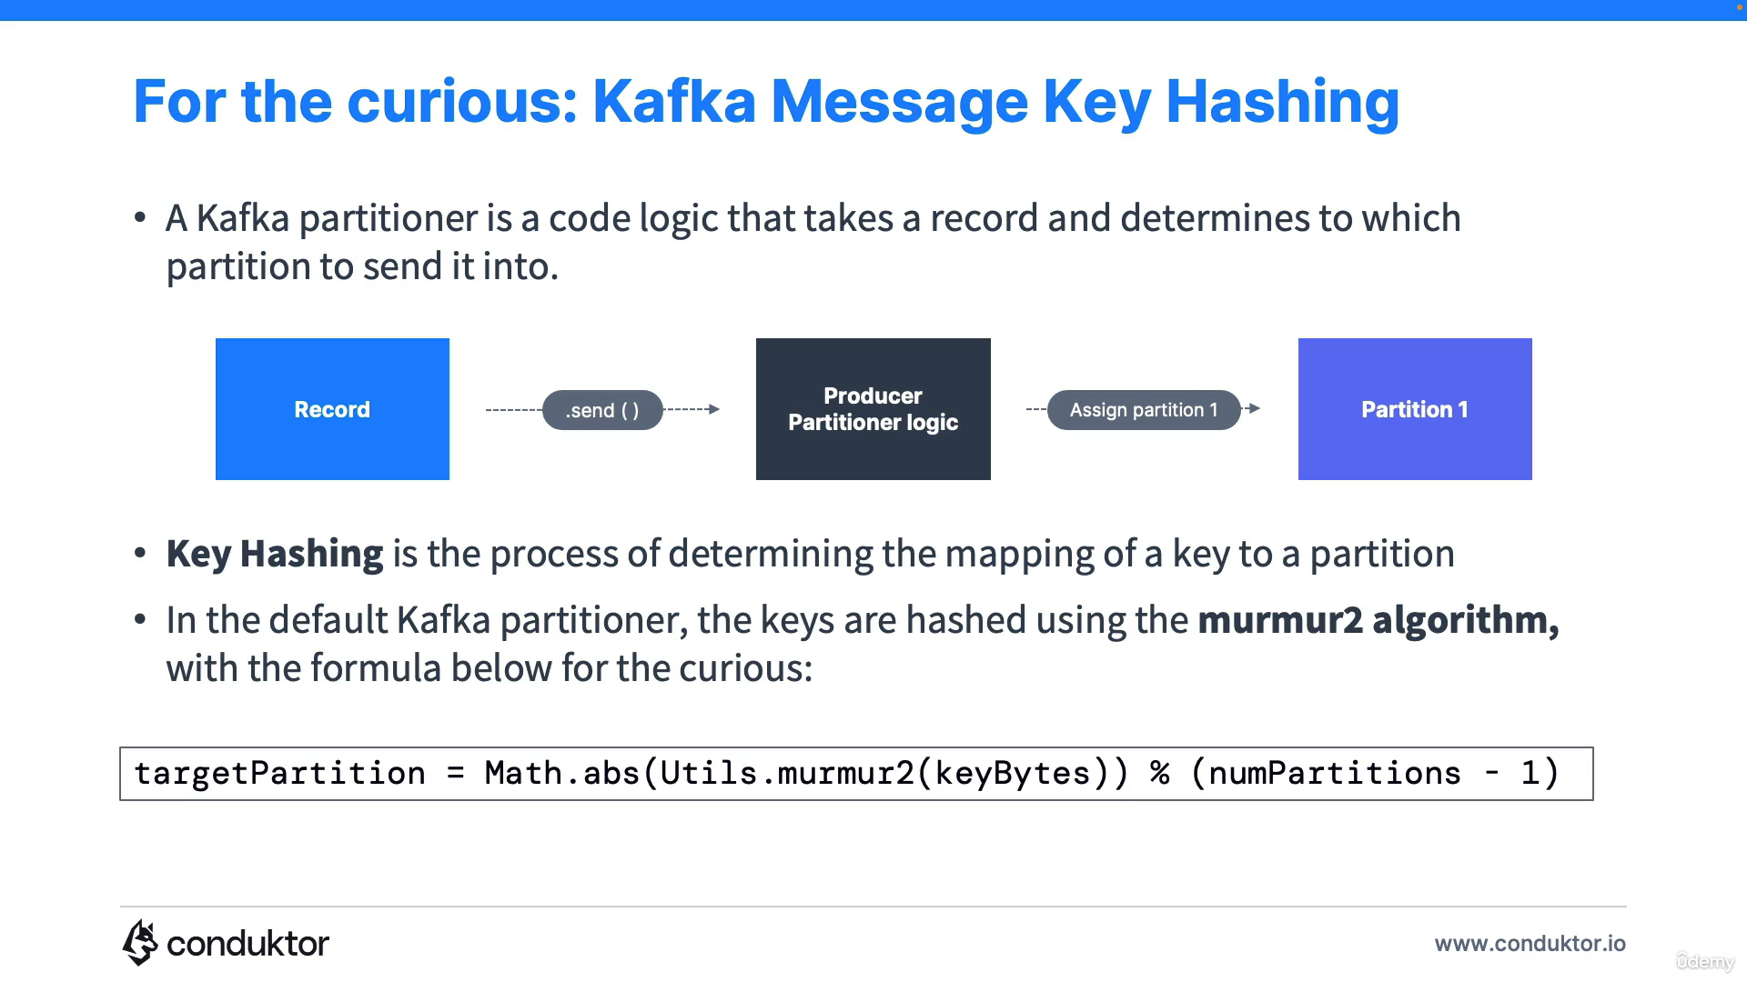

**Consumers**:

* Consumers automatically know which broker to read from.
* Data is read in order from low to high offset within each partition.

**Consumer Groups:**

* All the consumers in an application read data as a consumer groups.
* Each consumer within a group reads from exclusive partitions.

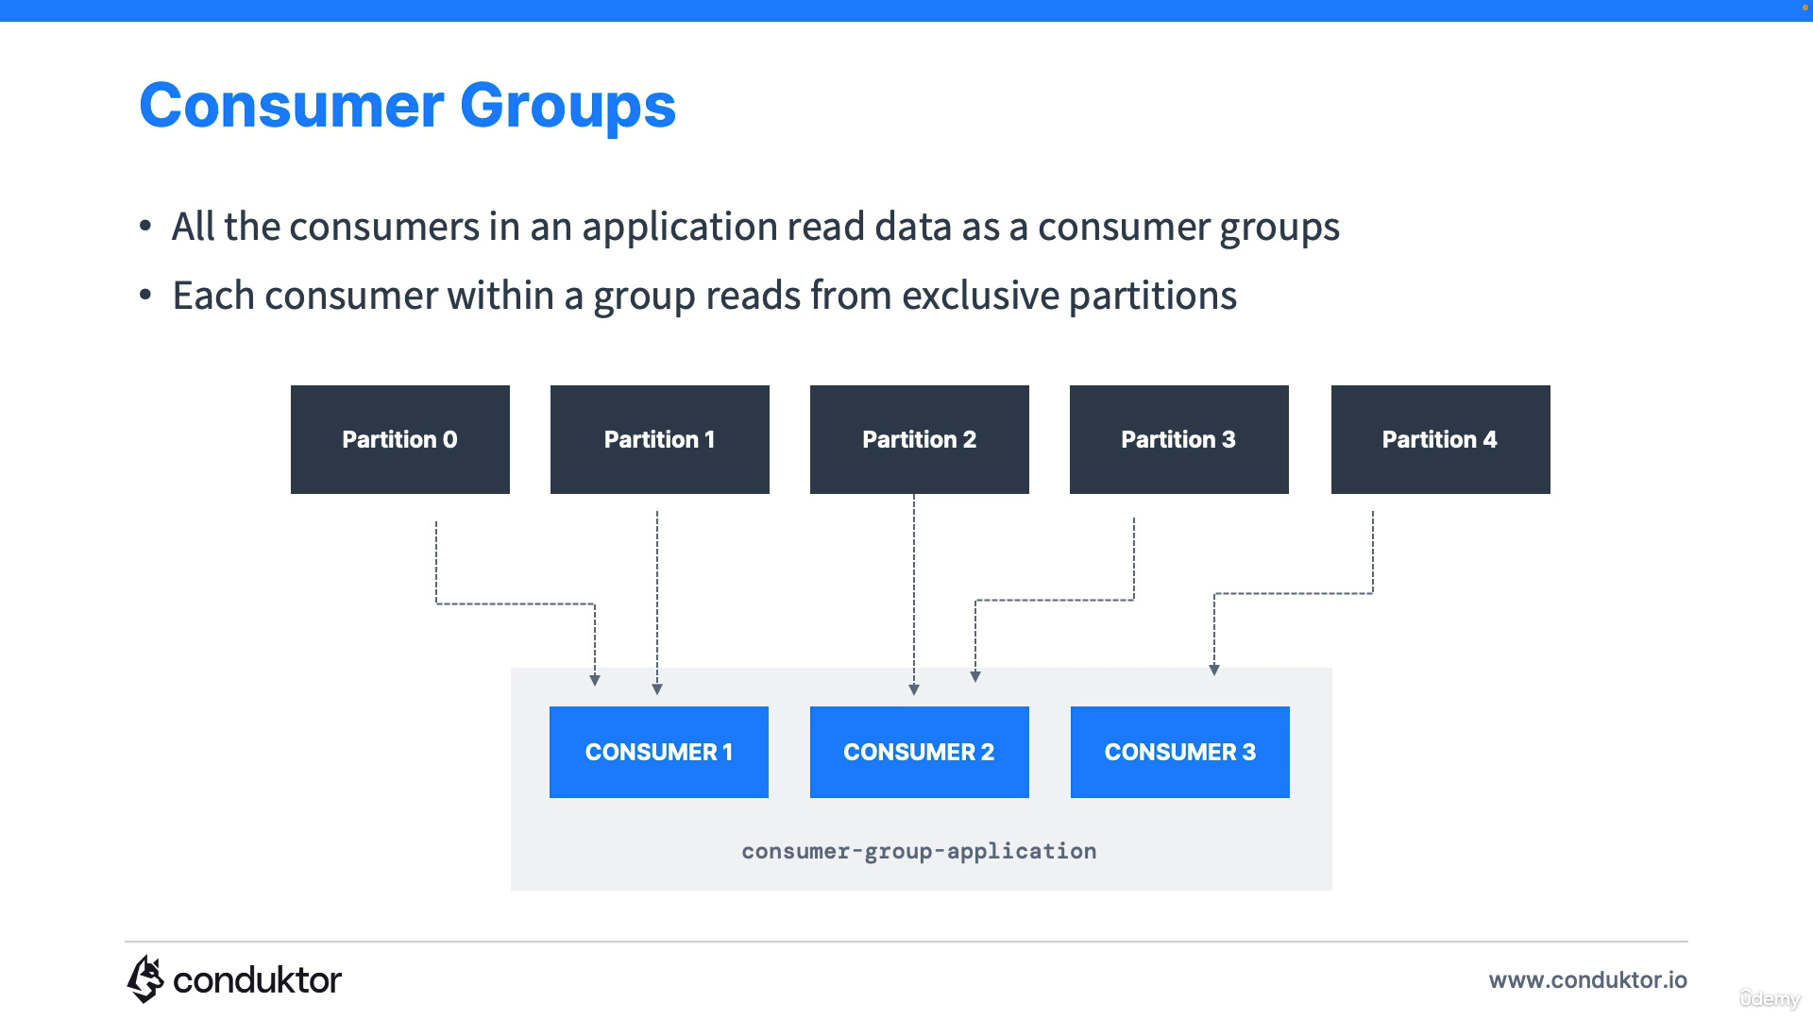

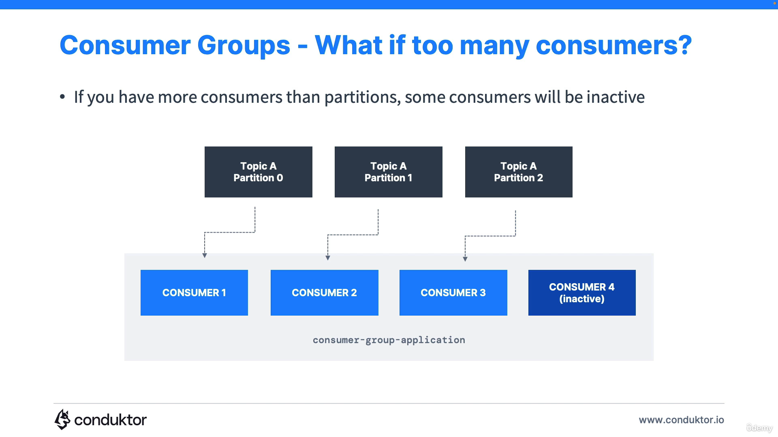

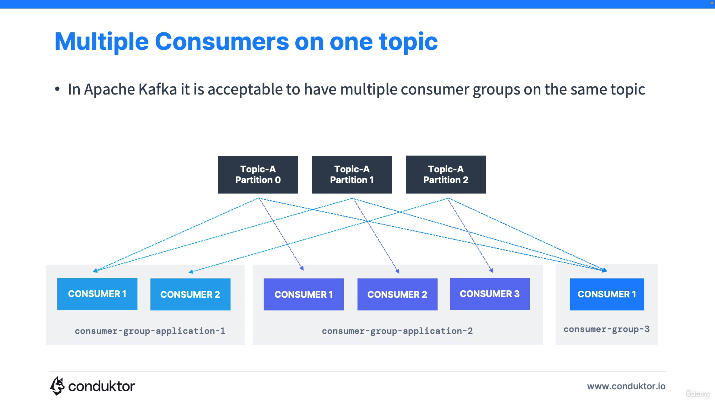

* Within a consumer group, only one consumer is going to be assigned to one partition.
* Why we have multiple consumer groups? Lets say trucks_gps topic, so here location service is one consumer group and notification service is another consumer group.
* To create distinct consumer groups, use the consumer property group.id

**Consumer Offsets:**

* Kafka stores the offsets at which a consumer group has been reading.
* The offsets committed are in Kafka topic named __consumer_offsets.
* When a consumer in a group has processed data received from Kafka, it should be periodically committing the offsets(the kafka broker will write to __consumer_offsets, not the group itself)
* If a consumer dies, it will be able to read back from where it left off.

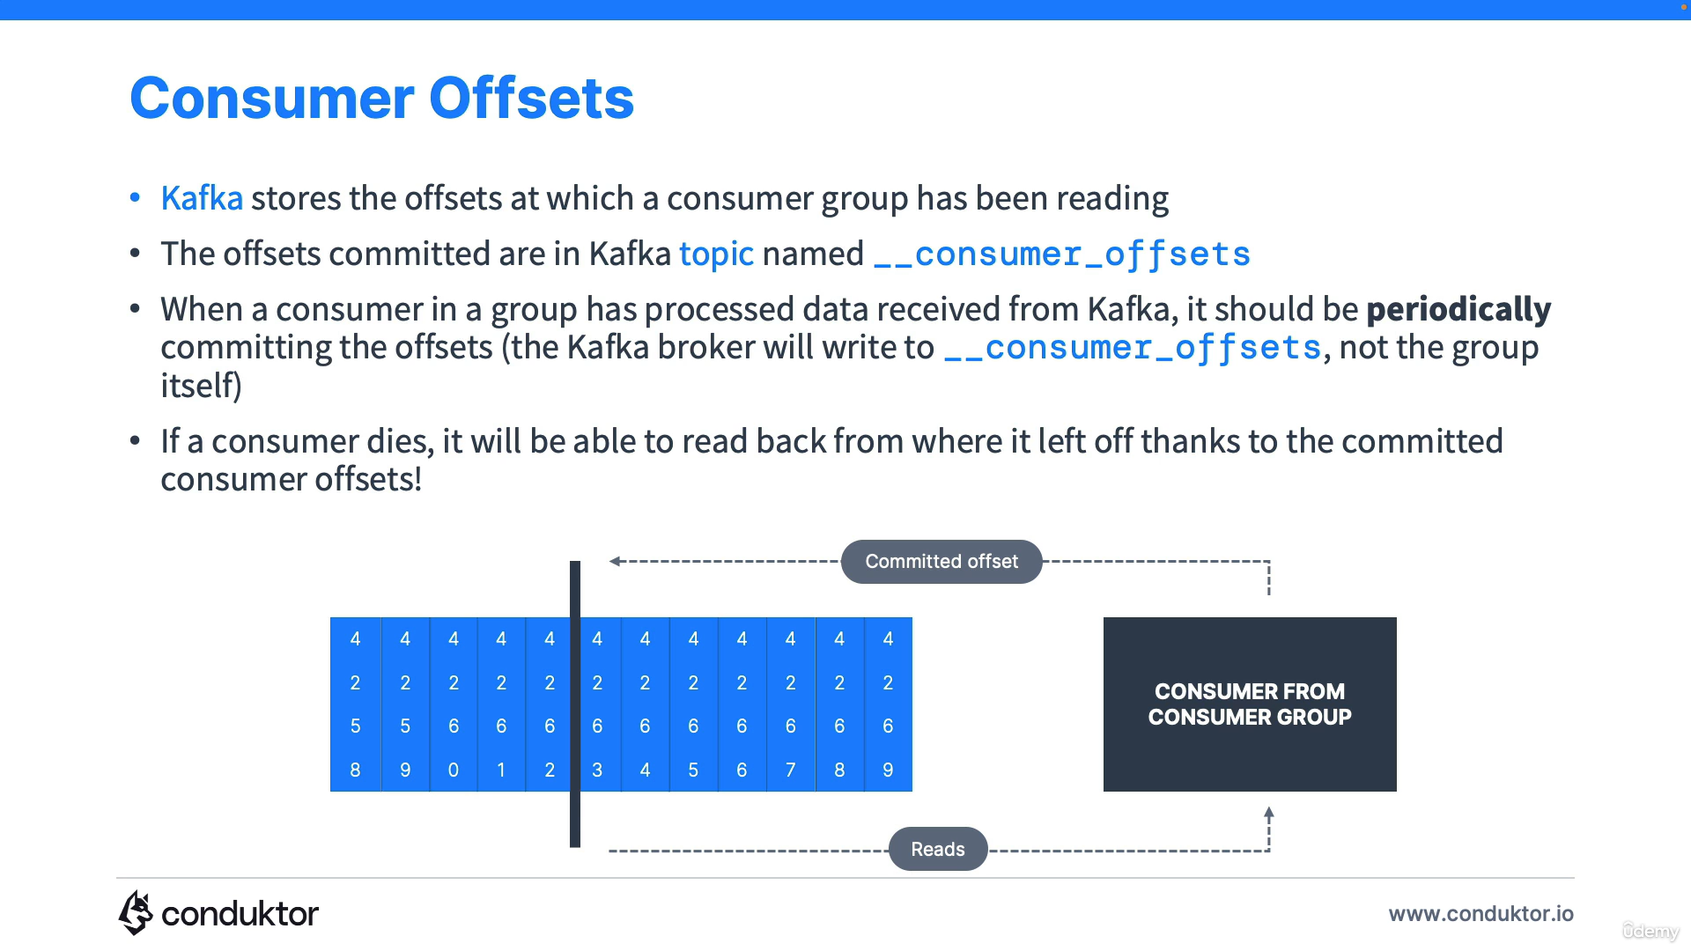

**Brokers:**

* A Kafka cluster is composed of multiple brokers (servers)
* Each broker is identified with its ID(integer)
* Each Broker contains certain topic partitions

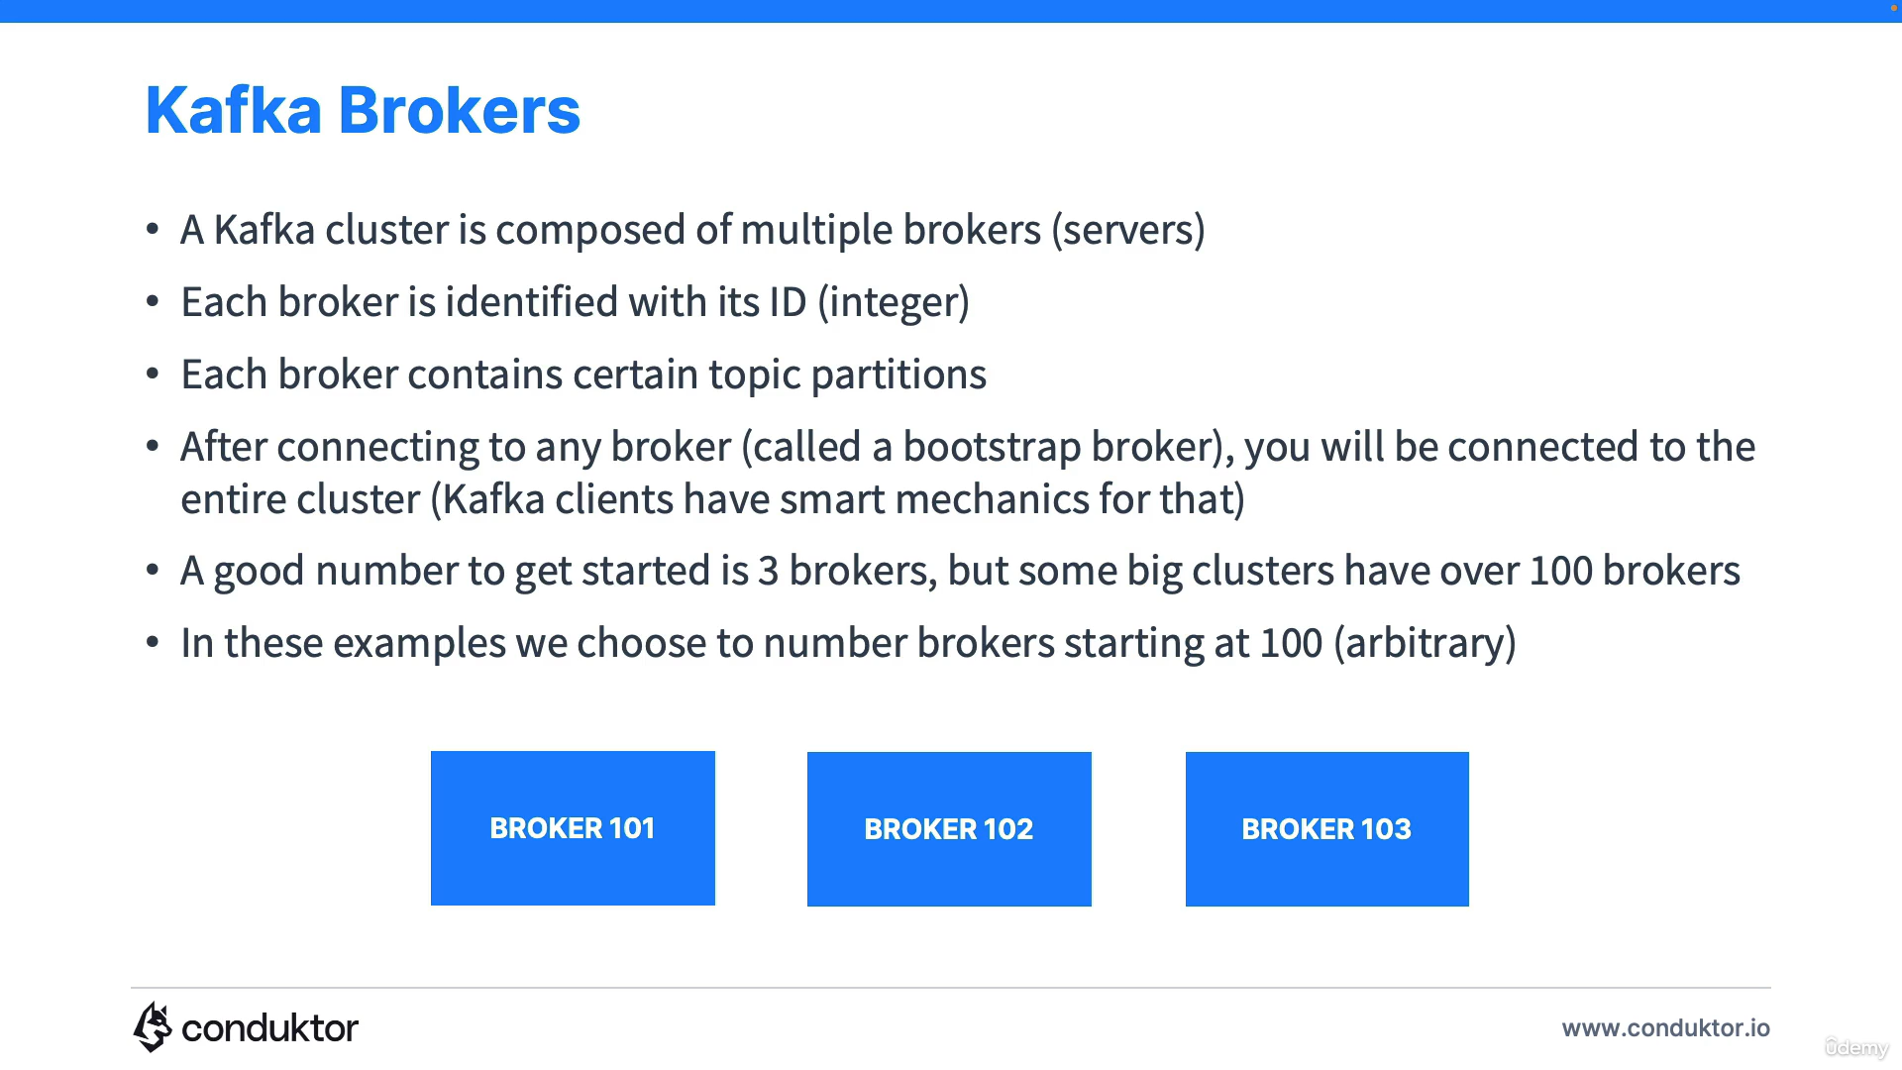

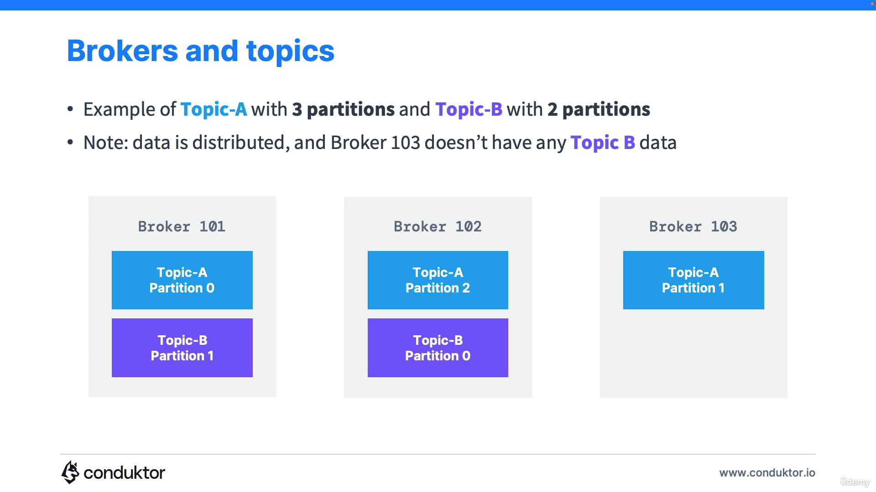

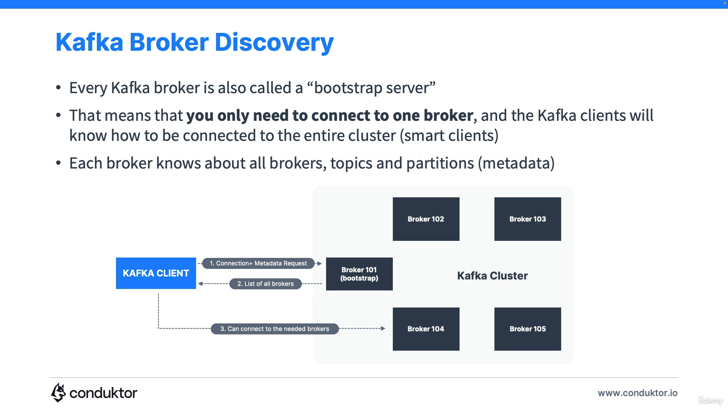

**Kafka Topic Replication factor:**

* Topics should have a replication factor > 1 (usually between 2 and 3)
* This way if a broker is down, another broker can serve the data.
* 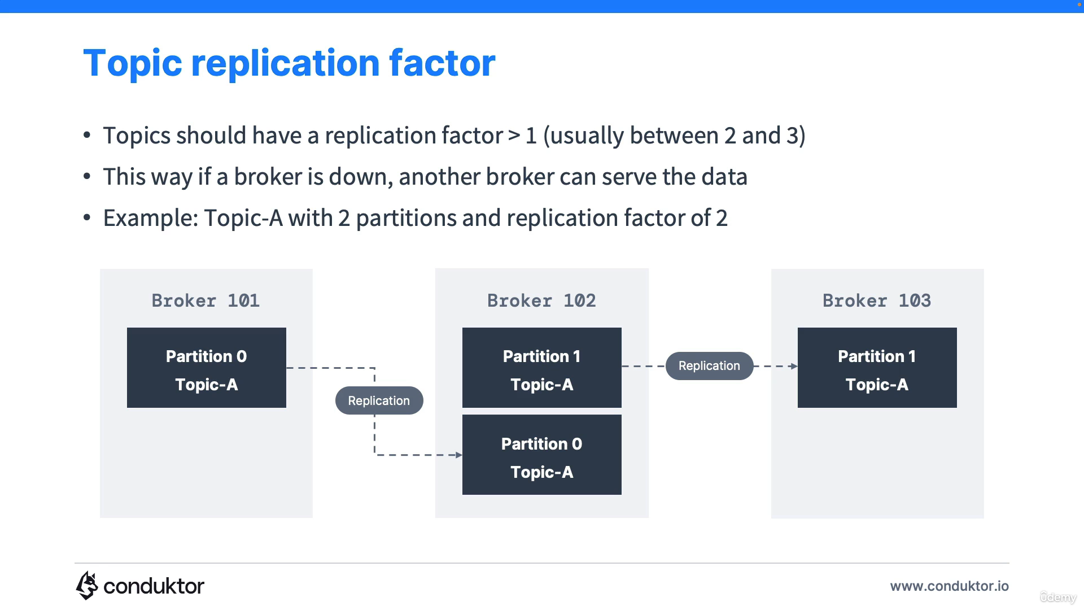

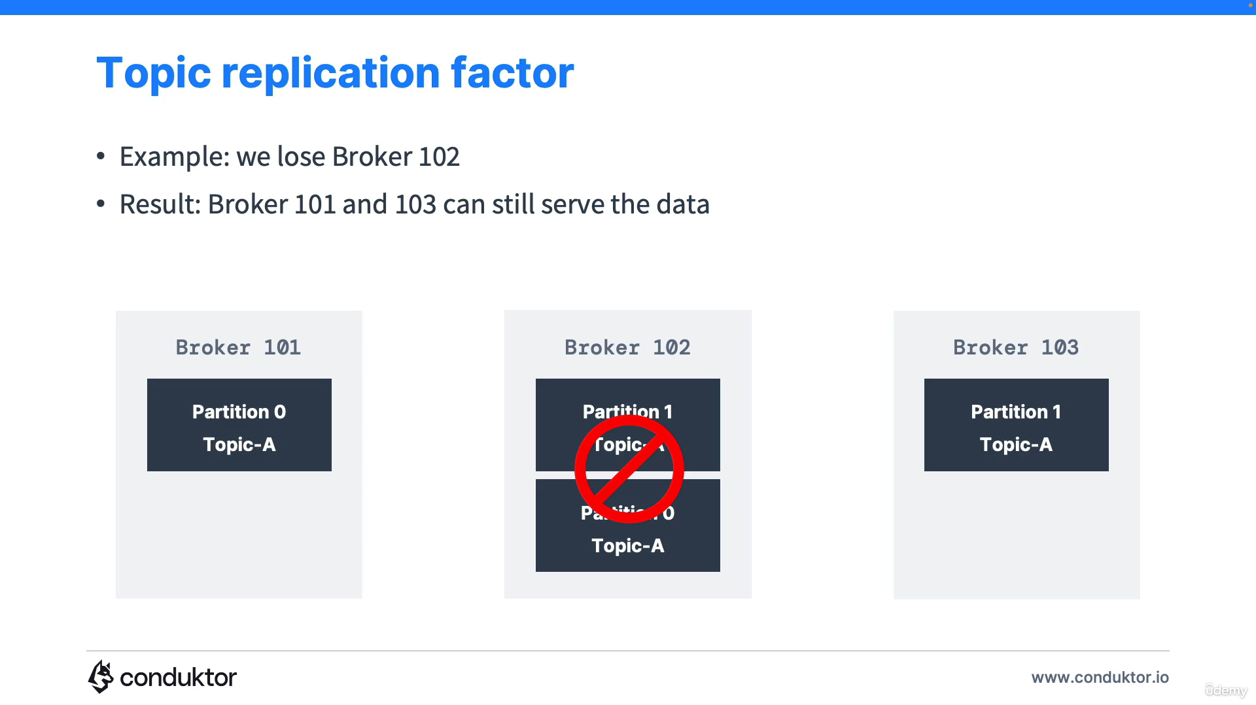

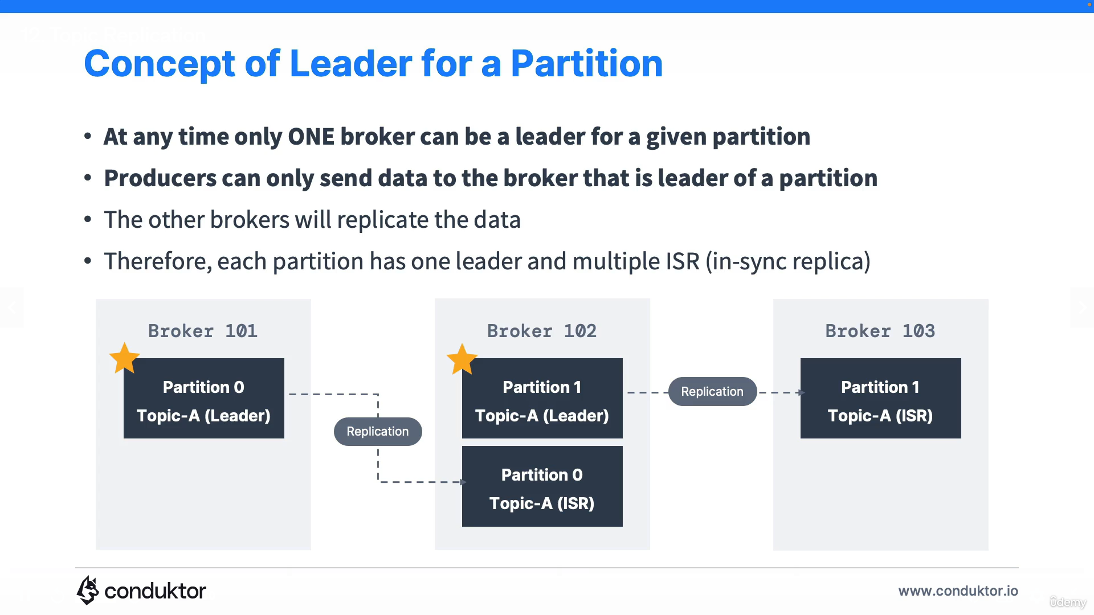

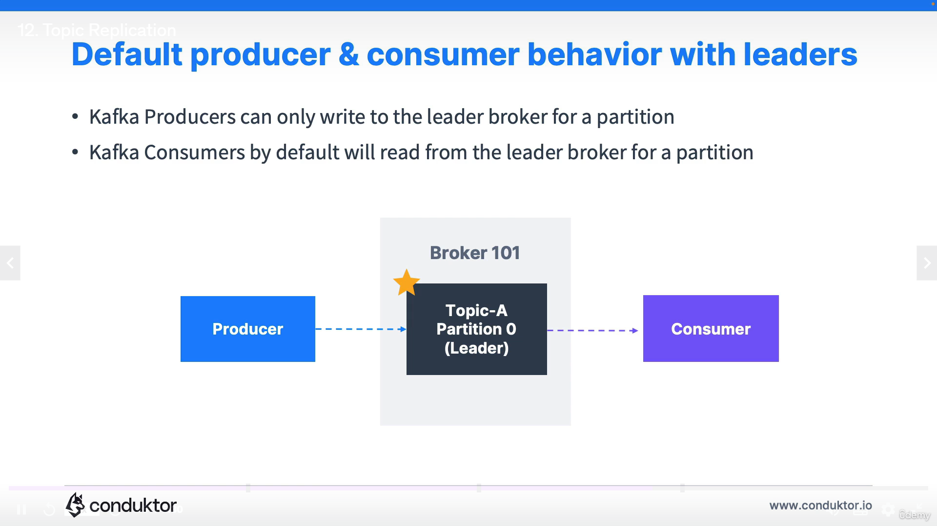

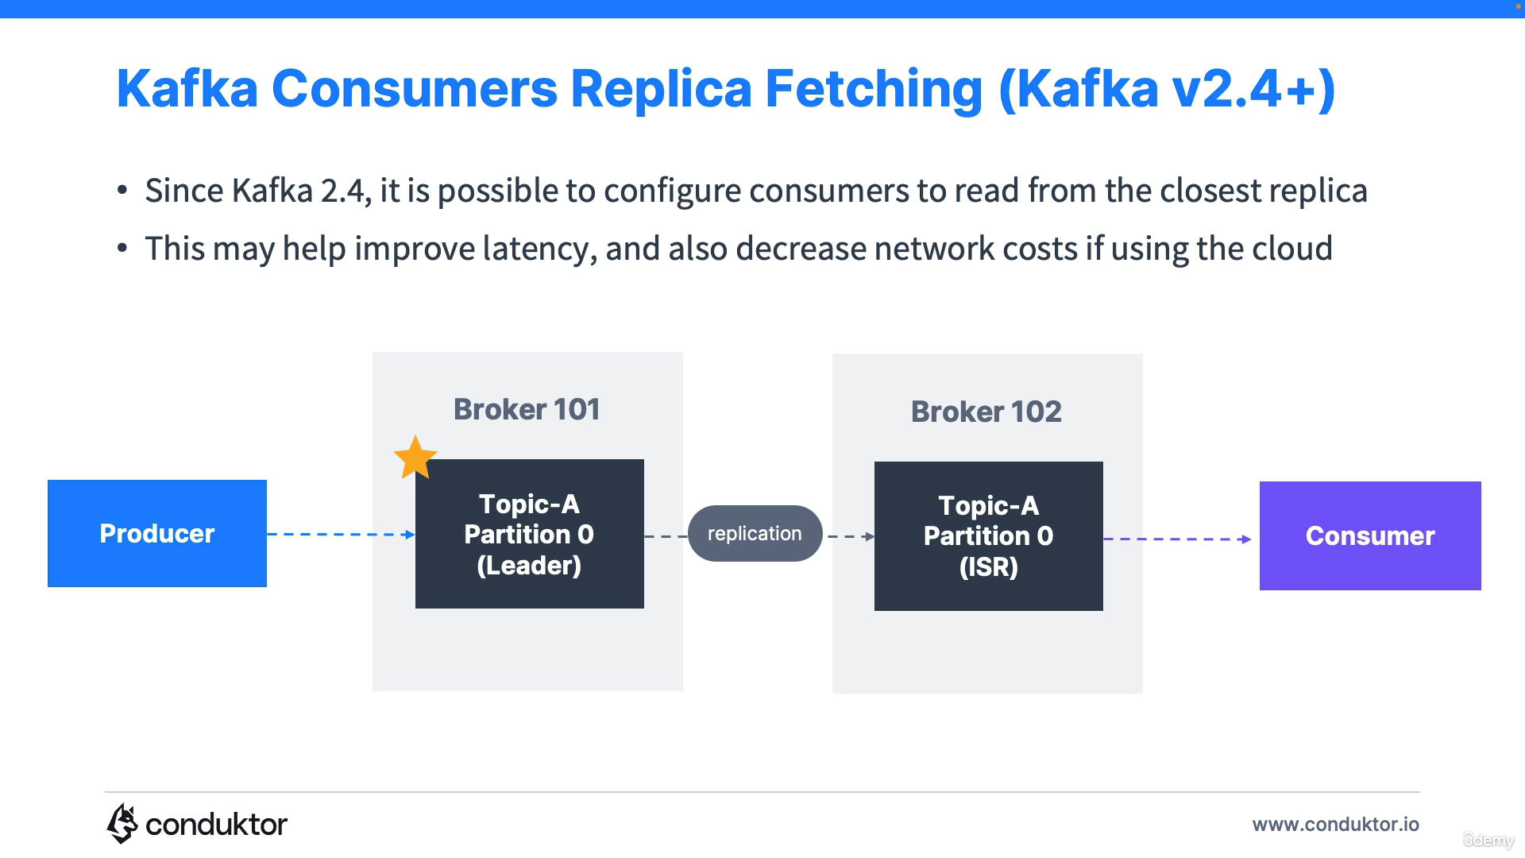

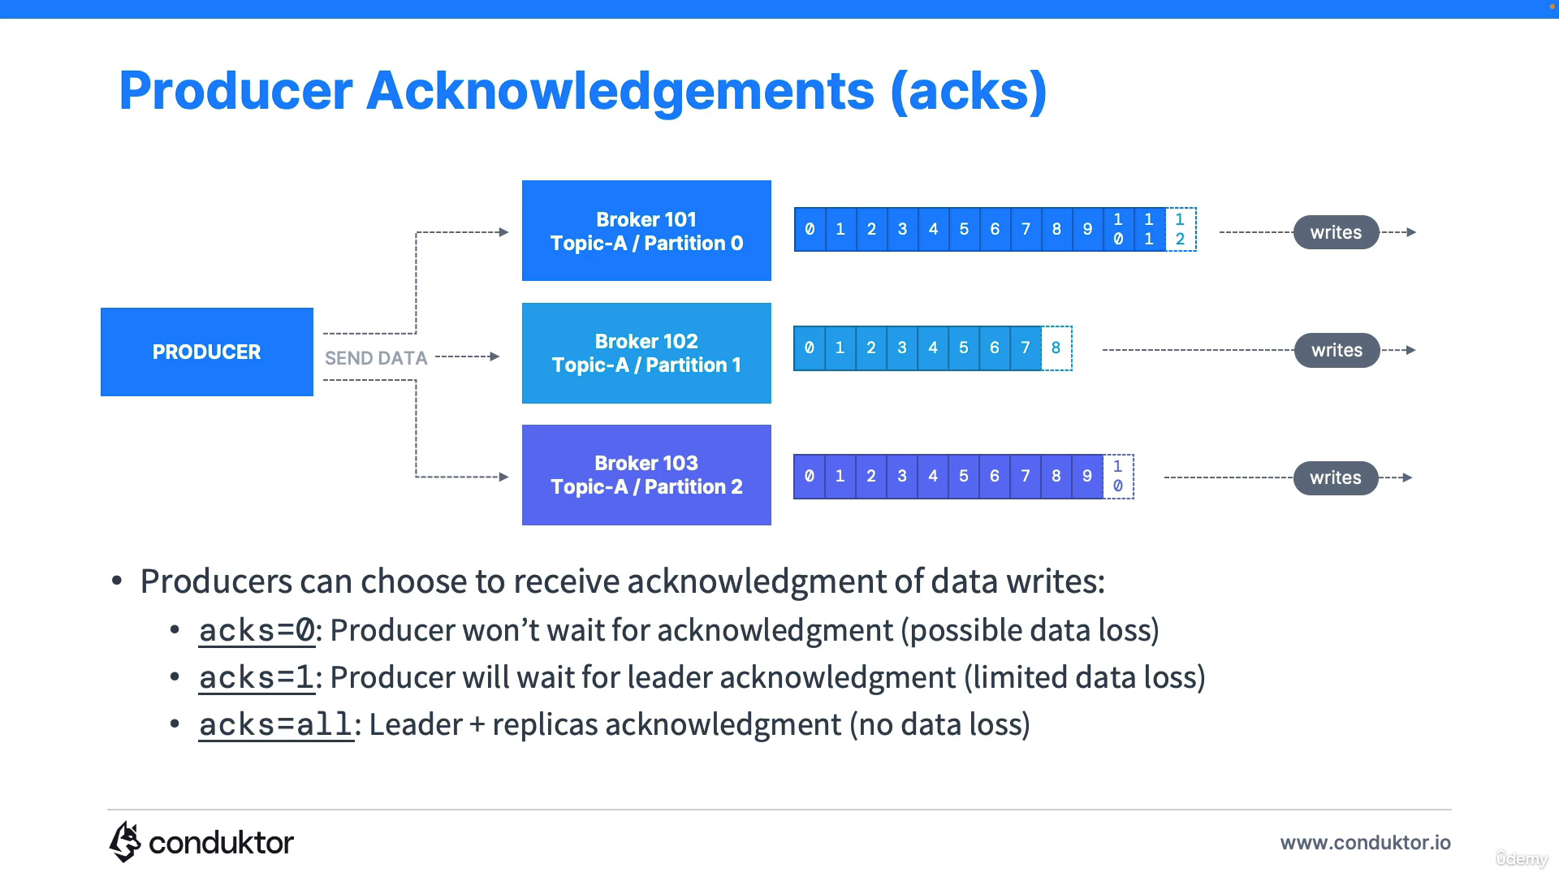

**Zookeeper:**

* Zookeeper manages brokers (keeps a list of them)
* Zookeeper helps in performing leader election for partitions.
* Zookeeper sends notifications to Kafka in case of changes (new topic, broker dies, broker comes up, delete topics etc)

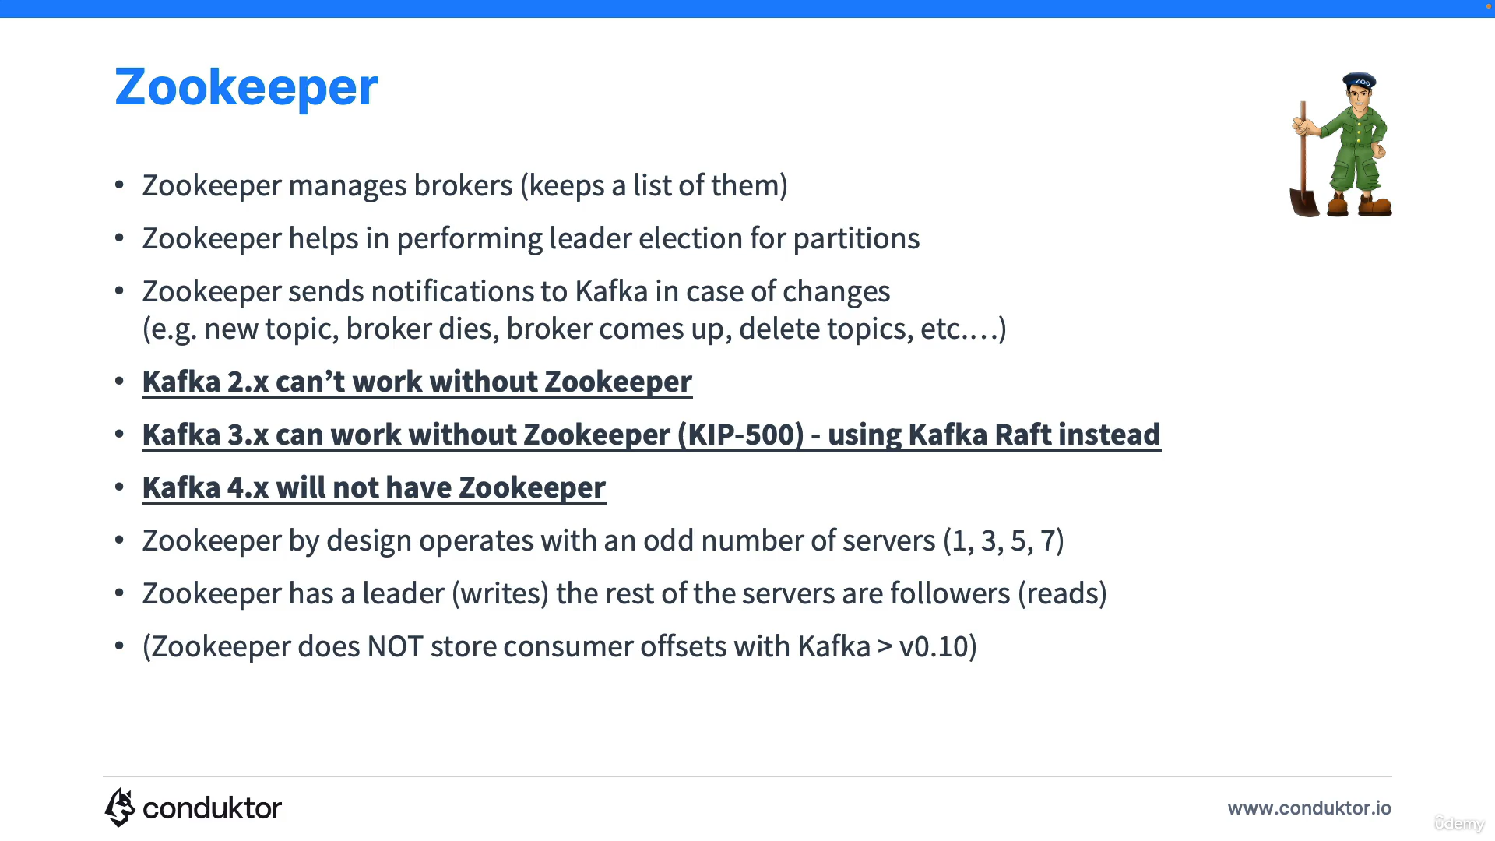

* kafka-topics.sh --command-config playground.config --bootstrap-server cluster.playground.cdkt.io:9092 --create --topic first_topic

--command-config playground.config – This is to pass on additional connection property to kafka which is necessary when you connect to secure Kafka cluster and

--bootstrap-server cluster.playground.cdkt.io:9092 – Kafka Server URL

### 1. Is getting message offset possible after producing?

This is not possible from a class behaving as a producer because, like in most queue systems, its role is to forget and fire the messages. As a message consumer, you get the offset from a Kaka broker.

### 2. How can the Kafka cluster be rebalanced?

When a customer adds new disks or nodes to existing nodes, partitions are not automatically balanced. If several nodes in a topic are already equal to the replication factor, adding disks will not help in rebalancing. Instead, the Kafka-reassign-partitions command is recommended after adding new hosts.